NOTES : CAESAR CIPHER SECURITY PROJECT

1. What does this task even mean?
Your task says:
“Create a Python program that can encrypt and decrypt text using Caesar Cipher.”
In simple words:
- You take a message like: HELLO
- You shift each letter by some number (called shift/key)
Example (shift = 3):
- H → K
- E → H
- L → O
- L → O
- O → R
✅ Result: KHOOR
This is called encryption (hiding message)
To get original message back:
- Shift backward (−3)
That is decryption

2. Why is this done?
This teaches:
- Basics of cybersecurity
- How encryption works
- Logic building
- Character manipulation in programming
Real-world:
- Passwords
- Banking systems
- Secure messaging
Caesar cipher is simple, but it's your first step into cryptography 🔐

3. What is “scripting” (from scratch)?
A script is just a program written to automate something.
Example:
- Calculator → script
- Login system → script
- This cipher → script
Python is called a scripting language because:
- Easy to write
- No complex setup
- Runs line by line

4. How should you THINK to solve this?
This is the most important part

Step 1: Break problem
You need:
- Take input text
- Take shift value
- Change each letter
- Show result

Step 2: Think about each character
Example:
Text = "ABC"
Shift = 2
You process:
- A → C
- B → D
- C → E
So you need a loop

Step 3: Think in terms of ASCII
Python stores characters as numbers:
Character | ASCII
A | 65
B | 66
a | 97
So:
ord('A') = 65
chr(65) = 'A'

Step 4: Core Logic
Formula (VERY IMPORTANT):
new_char = (old_char + shift) % 26
Why % 26?
Because only 26 letters (wrap around Z → A)

5. Now your code (you already have a strong version)
Let me explain YOUR code simply:

Core function (MAIN LOGIC)
def caesar_cipher(text, shift):
result = ""
for char in text:
Loop through each letter

if char.isalpha():
Only change letters (ignore numbers, spaces)

base = ord('A') if char.isupper() else ord('a')
Handle uppercase & lowercase separately

result += chr((ord(char) - base + shift) % 26 + base)
THIS IS THE HEART
Break it:
- ord(char) → convert letter to number
- - base → normalize (A → 0, B → 1…)
- + shift → apply shift
- % 26 → wrap around
- + base → convert back
- chr() → number → letter

Encryption
print(caesar_cipher(text, shift))

Decryption
print(caesar_cipher(text, -shift))
Same function, just negative shift 💡

6. Your extra features (this is ADVANCED )
Your file already includes:

✅ Brute Force Attack
Tries all shifts (1–25)

✅ Smart Attack
Shows top guesses

✅ File Encryption
Reads file → encrypts → saves

7. How to implement from scratch (step-by-step)

Step 1: Basic version

text = input("Enter text: ")

shift = int(input("Enter shift: "))

result = ""

for char in text:

if char.isalpha():

if char.isupper():

base = ord('A')

else:

base = ord('a')

result += chr((ord(char) - base + shift) % 26 + base)

else:

result += char

print(result)

Step 2: Add function
def caesar_cipher(text, shift):
...

Step 3: Add decrypt
caesar_cipher(text, -shift)

Step 4: Add menu
1. Encrypt
2. Decrypt

Step 5: Add advanced features (like your code)

8. Common mistakes students make
❌ Forget % 26 → gives wrong letters
❌ Not handling uppercase
❌ Not handling spaces
❌ Using only + shift (no wrap-around)

9. Interview / Viva questions (important!)
👉 What is Caesar Cipher?
👉 Why modulo 26 is used?
👉 Difference between encryption & decryption?
👉 What is brute force attack?
👉 Is Caesar Cipher secure? (Answer: ❌ No)

10. Final mindset (this is gold )
When you see any coding problem:
Ask:
- What is input?
- What is output?
- What transformation is happening?
Then:
- Break into steps
- Handle one unit (character here)
- Use loop
- Apply formula

11. Reality check (important)
Your current code is already:
- Clean ✔
- Feature-rich ✔
- Logical ✔
Honestly? This is better than what most students submit

What is Cryptography?
Cryptography is the technique of protecting information by converting it into a form that only authorized people can understand.
Simple idea:
- You send a message → it gets scrambled
- Only the receiver can unscramble it

Real-life example:
When you send a message on WhatsApp, it’s encrypted using cryptography so no hacker can read it.

Basic Terms (VERY important)
- Plaintext → Original message
Example: HELLO
- Ciphertext → Encrypted message
Example: KHOOR
- Encryption → Converting plaintext → ciphertext
- Decryption → Converting ciphertext → plaintext

What is Caesar Cipher?
Caesar Cipher is one of the simplest encryption techniques.
It was used by Julius Caesar to send secret military messages.

How It Works
You shift each letter of the message by a fixed number.
This number is called the key

Example (Shift = 3)
Original | Shift +3 | Result
H | +3 → K | K
E | +3 → H | H
L | +3 → O | O
L | +3 → O | O
O | +3 → R | R
Final Encrypted Message: KHOOR

Formula (Simple logic)
For encryption:
Encrypted Letter = (Original Letter + Shift) % 26
For decryption:
Original Letter = (Encrypted Letter - Shift) % 26
% 26 is used because there are 26 letters in the alphabet

Visualization

Plain → Encrypted (Shift 3)
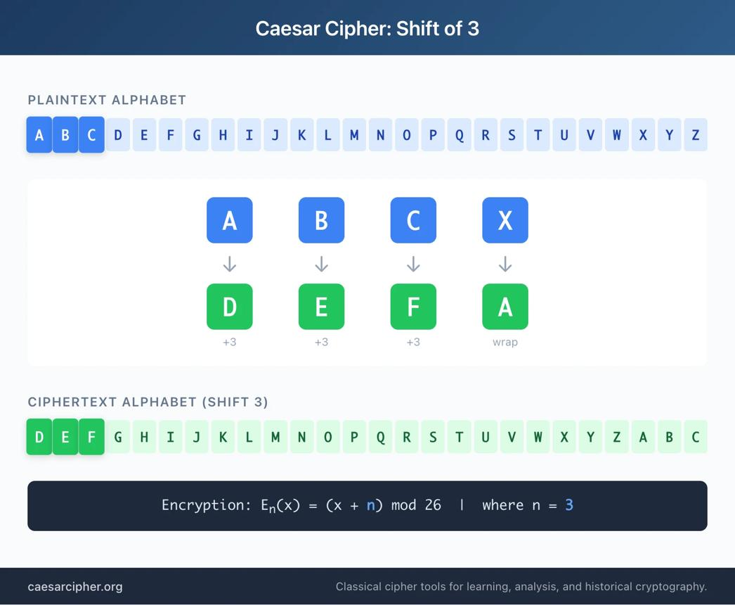
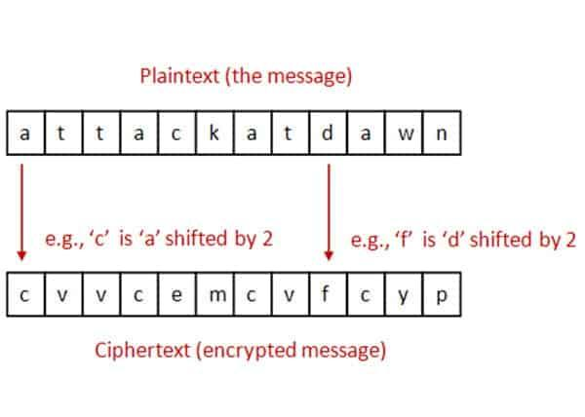
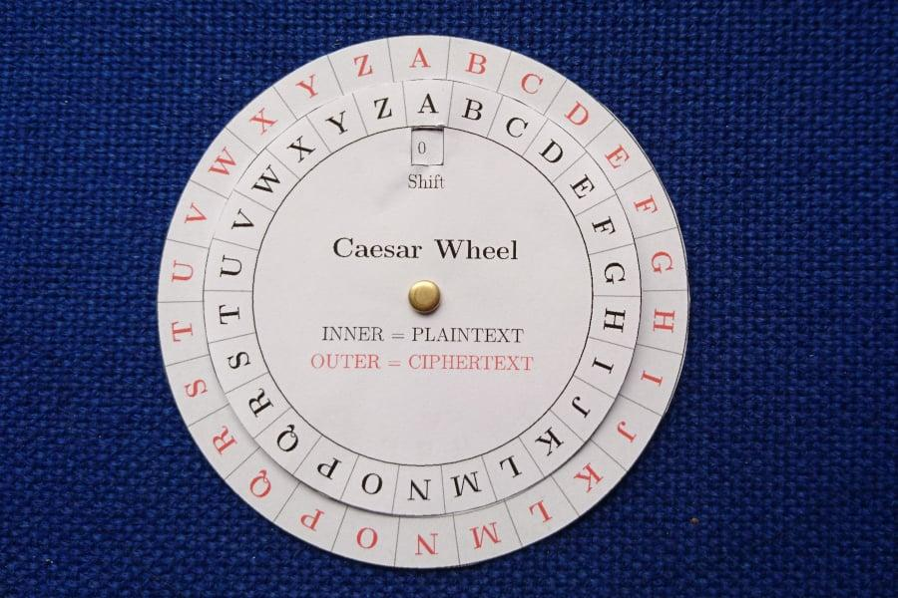
6

Why is Caesar Cipher Important?
Even though it's simple, it teaches:
- Basic idea of encryption
- How keys work
- Foundation of modern cybersecurity

Weakness
Caesar Cipher is NOT secure today ❌
Why?
- Only 25 possible shifts → easy to try all (brute force attack)

Simple Logic (How YOU should think)
If you want to build this in code:
- Take input message
- Take shift value
- For each letter:
  - Convert to number (A=0, B=1…)
  - Add shift
  - Apply % 26
  - Convert back to letter
- Print encrypted message

Real Understanding (Important Insight)
Think of Caesar Cipher like:
"Rotating the alphabet"
Normal: ABCDEFGHIJKLMNOPQRSTUVWXYZ
Shift 3: DEFGHIJKLMNOPQRSTUVWXYZABC

Quick Summary
- Cryptography = protecting data
- Caesar Cipher = shifting letters
- Key = shift number
- Encryption = scrambling
- Decryption = getting original

The Formula
new_char = (old_char + shift) % 26
This works on numbers, not letters directly.

Step 1: Convert letters → numbers
We first convert letters into numbers like this:
A → 0
B → 1
C → 2
...
Z → 25
So if you have:
- A → 0
- C → 2
- Z → 25

Step 2: Add the shift
Suppose:
old_char = 2 (which is C)
shift = 3
Then:
old_char + shift = 2 + 3 = 5

Step 3: Why % 26 is used?
Because there are only 26 letters.
If the value goes beyond 25, we need to wrap around 🔄
That’s what % 26 (modulus) does.

Example 1 (Normal case)
C → 2
shift = 3
new_char = (2 + 3) % 26 = 5
5 → F
✅ So, C → F

Example 2 (Wrap-around case)
Z → 25
shift = 3
new_char = (25 + 3) % 26 = 28 % 26 = 2
2 → C
✅ So, Z → C (wrapped around)

Intuition (VERY IMPORTANT 💡)
Think of it like a circular wheel of alphabets:
A → B → C → ... → Z → back to A
- You move forward by shift
- If you cross Z, you come back to A

Why exactly % 26?
Because:
- % gives the remainder
- It keeps the value always between 0 and 25
So no matter how big the number becomes, it stays within alphabet range.

Final Flow in Code Thinking 🧠
- Take letter
- Convert to number (ord(char) - ord('A'))
- Apply:
(old + shift) % 26
- Convert back to letter

Super Simple Summary
👉 + shift = move forward
👉 % 26 = stay inside alphabet by wrapping

